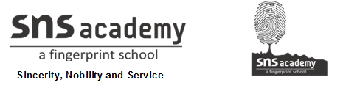
MONTHLY TEST- DECEMBER 2019
Marks obtained:

Total:
30
Name: ________________________
Grade: II Section___
Subject: EVS
Date: 18.12.2019
Time: 1 Hour

I. Dictation. (5x1=5)
1. ________________
2. ________________
3. ________________
4. ________________
5. ________________
II. Fill in the blanks using the given help box. (5x1=5)
animals, soap, library, doctor, trees

6. _____________ is a place where we read and borrow books.
7. Wash hands with _________________ before and after eating.
8. The quality of air is affected when we cut down ______________.
9. A_____________ treats people who are sick and hurt.
10. Plants, ___________ and people breathe in air.

III. Match the following. (5x1=5)
11. chicken pox hospital
12. hand recreational place
13. ambulance vegetables and fruits
14. mall air borne diseases
15. local market soap
IV. State whether the following sentences are true or false. (5X1=5)
16. Air is blue in colour.
17. We must always throw rubbish in garbage bins.
18. We must talk to strangers when we visit public places.
19. Air is found everywhere.
20. Public places are used by everyone in the neighbourhood.

V. Answer the following. (3x2=6)
21. Why is air important?
____________________________________________________________
____________________________________________________________
____________________________________________________________

22. Give examples of recreational places.
____________________________________________________________
____________________________________________________________
____________________________________________________________
23. Write any two rules to follow in public places.
____________________________________________________________
____________________________________________________________
____________________________________________________________
VI. Create a poster on one effect of air pollution. (4)

